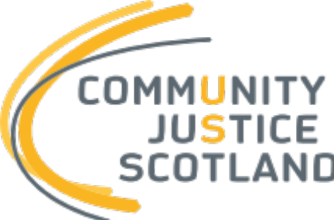

Corporate Plan Consultation

September 2026

Overview
We are seeking feedback on the CJS proposed corporate plan for the period 2027-2032.
You can view the draft CJS Corporate Plan here: Corporate Plan 2027-2032 - Consultation - Community Justice Scotland.
Your responses will help us ensure that partners and stakeholders views are fully considered in our plan prior to publication, anticipated by the end of March 2027. This time frame will also allow the emergent CJS corporate plan to consider any implications which may arise from the current consultation on the National Strategy for community justice by Scottish Government.
Consultation responses can be submitted using the MS Form or by completing this Word form and emailing it to info@communityjustice.scot.
The consultation period will close at 5pm on Friday 30th October 2026.

Section 1 – Participant information
- Full name [required]
Click or tap here to enter text.
- Contact email [required]
Click or tap here to enter text.
- Are you completing this questionnaire [required]:
☐ As an individual [proceed to question 5]
☐ On behalf of an organisation
- If responding on behalf of an organisation, please provide the organisation's name [required]:
Click or tap here to enter text.

Section 2
The plan introduces four strategic objectives for CJS, as outlined below, with underpinning actions.
Strategic Objectives | Strongly agree | Agree | Neither agree nor disagree | Disagree | Strongly disagree
Objective 1:  Drive a more preventative and joined-up justice system | ☐ | ☐ | ☐ | ☐ | ☐
Objective 2: Build confidence, consensus and a stronger community justice narrative | ☐ | ☐ | ☐ | ☐ | ☐
Objective 3: Drive standards and improve practice across community justice | ☐ | ☐ | ☐ | ☐ | ☐
Objective 4: Strengthen evidence, insight and intelligence across community justice | ☐ | ☐ | ☐ | ☐ | ☐
- For each objective, please indicate the extent to which you agree that it should be a priority for Community Justice Scotland over the life of the Corporate Plan [required, select one option for each objective]

- Please use the following space to expand on your responses

Click or tap here to enter text.

- As a public body, CJS is required to fulfil our public sector equality duty in the development of our corporate plan. Our commitment to equalities is addressed in the proposed cross-cutting themes outlined at section 6 of the plan. Please indicate the extent to which you agree that these cross-cutting themes help CJS address and reduce inequality [required, select one option]

Strongly agree | Agree | Neither agree nor disagree | Disagree | Strongly disagree
☐ | ☐ | ☐ | ☐ | ☐

- Please use the following space to expand on your response. This can include any other suggestions for how CJS could further promote equality, diversity and inclusion in its work.
Click or tap here to enter text.

- Do you have any further general reflections on the corporate plan which you would wish CJS to consider?
Click or tap here to enter text.

