Community Justice Scotland
Ceartas Coimhearsnachd Alba

Head of Commissioning
Recruitment Pack

February 2021

Contents

- Overview

- Your Role: Your Strengths

- Essential criteria

- How to Apply

1 Overview

Launched on 1 April 2017 by the Community Justice (Scotland) Act 2016, Community Justice Scotland (CJS) is the national body for community justice in Scotland. Find out more: https://communityjustice.scot/

- We provide leadership, training and insight to support partners to prevent offending and reduce the number of future victims.
- We work to change the conversation about justice, increasing understanding and support for what will make Scotland better for all of us.
- We give expert evidence and detailed briefings to parliament, helping to shape laws and policies to be the best they can for everyone in our community.
- We work with our partners and help drive change by identifying improvements and challenges in our community justice system.
- We identify worldwide expertise, best practice, and introduce fresh ideas which inspire innovation and change.

Our vision is to make Scotland a safer place to live by leading and promoting world-class standards of community justice. This will only be possible with support from across our society, including from partners, third sector, those impacted by the justice system, the public and beyond.

Role: Head of Commissioning
Salary: £48,930 - £61,006
Contract: Permanent
Location – Edinburgh based, currently remote working

2 Your role: your strengths

The Head of Commissioning role will lead the development of a plan, in consultation with stakeholders, that will detail the pathway to transferring responsibility of commissioning Throughcare and Mentoring services, currently provided by Public Service Partnerships (PSPs), from Scottish Government (SG) to Community Justice Scotland (CJS). This plan will be subject to approval by Scottish Ministers. The Head of Commissioning will thereafter manage the implementation of the approved plan.

Once transition has been achieved the Head of Commissioning with lead on commissioning and procurement of services of Throughcare/Mentoring services for women and men transitioning from custodial sentences into the community. A primary focus will be to apply the Strategic Commissioning Framework demonstrate its effectiveness in promoting positive outcomes for service users and to undertake any reviews of the Framework as required.

The Head of Commissioning of will have a strong understanding and experience of commissioning services, they will have a knowledge of the complexities around designing and delivering effective commissioning of services; including the role of procurement. They will have a rich understanding of evaluation methods, reporting standards and monitoring of services.

The Head of Commissioning will understand the community justice and broader justice landscapes including the role of key partners and the third sector. The post holder must be able to work effectively within a multi-agency environment.

To ensure that we help people across Scotland to achieve their potential you will have:

Essential
- Previous commissioning experience
- Building and maintaining stakeholder relationships
- Experience of strategic planning and monitoring within a local and/or national context
- Delivering commissioning activity in a multiagency environment
- Experience in report writing for local and/or national audiences using a range of data sources, and the ability to monitor and report on progress towards an outcome-focussed action plan
- Experience in stakeholder engagement with a range of partners
- Excellent attention to detail
- Excellent problem solving skills
- Ability to analyse and interpret complex information from a range of sources to inform strategic decision making
- Understanding of Scottish criminal justice and community justice processes
- Working in a senior environment and being able to influence stakeholders
- Planning, monitoring and evaluation skills
- Knowledge of procurement processes

5 How to Apply

Please send us an up to date CV and a covering letter including how you meet the essential criteria for this post.

If you have any questions, please do not hesitate to get in touch via at
HR@communityjustice.scot

Closing date for applications is Friday 5 March 2021 at midday, interviews w/c 15 March 2021.

Any questions you can contact Nina Rogers, Head of People on 07557 647 849.

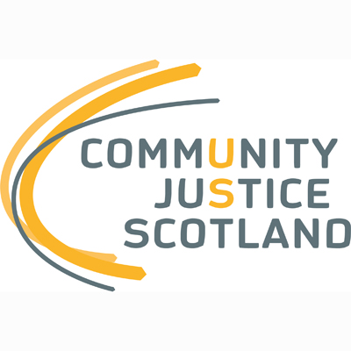

First published December 2020

Community Justice Scotland
R1 Spur
Saughton House
Broomhouse Drive
Edinburgh
EH11 3DX

Tel:0300 244 8420

www.communityjustice.scot

