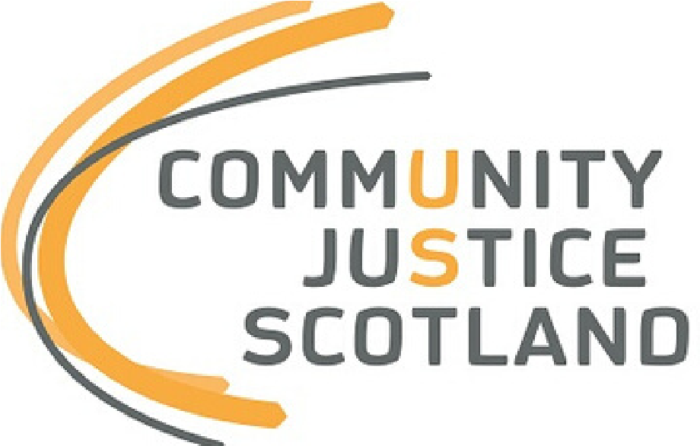
Strategic Needs and Strengths Assessment
Alternatives to Prosecutorial Action : Diversion from Prosecution
Template and Guidance for
Community Justice Partnerships

[insert publication date here]
About this Template
Strategic needs and strengths assessment (SNSA) is the foundation on which an area can understand the needs of their population and the services and interventions that are in place locally. SNSA will facilitate evidence-led planning to effectively address the needs of individuals in a local area. A full SNSA should provide a comprehensive overview of community justice in that locality and the needs, issues and strengths specific to that area. Guidance supporting the production of a full SNSA was issued by CJS in February 2020.
In March 2020 the COVID-19 pandemic struck and had, and continues to have, a significant impact on every part of life including the justice system. Community justice-based agencies have toiled to maintain delivery of essential services against a backdrop of changing priorities and varying degrees of intermittent lockdowns. Throughout the period of the pandemic people and partners have sought innovative and creative ways to support the most vulnerable in our communities and sustain critical activity around public protection whilst recognising that workers are also struggling with health, care and self-isolation issues.
The impact of this on activities such as strategic planning has been considerable, particularly on key tasks such as the development of local SNSAs and Community Justice Outcome Improvement Plans (CJOIPs). Following a meeting with the Community Justice Network in September 2020, and three CJS-led briefing sessions with CJP chairs, it was agreed that providing some guidance as to how strategic planning for community justice might be best approached during lockdown and into recovery would be of some benefit.
The CJS (and legislative) position is that every area should have an up-to-date CJOIP, populated through the process outlined in the SNSA guidance. Where this is not possible, CJS have set out a minimum expectation that local areas focus on three specific areas of activity to produce targeted SNSA reports:
- Arrest Referral | - Diversion | - Bail Support and Supervision

This template builds on the SNSA guidance and provides more detail about how to produce a targeted SNSA report in respect of diversion from prosecution. The template contains an overview of diversion, nationally, including key principles and key roles. National and local data sources which will help to develop demographic, need and service profiles are outlined and examples are included of how data might be presented using narrative and visual descriptions. Guidance is included in how to approach horizon scanning, the analysis of the data and the development of recommendations and priorities.
The national data within this template can be used by every area in Scotland but it is essential that it is supplemented with local data and information. Only by doing this will CJPs understand the local needs of their population and the services and interventions that are in place locally. Guidance on the methods and considerations for collating local data and information are signified throughout this template by a signpost icon.
The primary purpose of this template is to assist CJPs to begin to, where they have not previously, engage in a measured and supported way with the SNSA process as a means of creating, revising or developing their local CJOIP. The completion of targeted SNSA reports will begin the process towards a full SNSA and will provide assurance to CJPs (and to CJS when local areas, as is legally required, consult with us about new CJOIPs) that local outcomes and priorities are robustly evidence-based.

Local Authority Area:

Overview | What is diversion from prosecution?  Diversion from prosecution is a process by which the Crown Office and Procurator Fiscal Service (COPFS) are able to refer a case to a local authority as a means of addressing the underlying causes of alleged offending when this is deemed the most appropriate course of action.  The national diversion from prosecution guidance outlines that diversion from prosecution should be considered in any case where the individual reported to COPFS has an identifiable need and where it is assessed that diversion from prosecution is the most appropriate outcome in the public interest.  The aim of diversion from prosecution can be outlined as follows:  - To provide a disposal which, due to the circumstances of the individual and the circumstances of the alleged offence, provides an appropriate person-centred response.  - To enable a swift intervention, which can interrupt a cycle of offending and/or prevent further offending.  The benefits of a successful diversion from prosecution are three-fold:  - It allows the individual an opportunity for support to deal with the issues personal to them in the context of the alleged offence (from a desistance perspective).  - Avoiding unnecessary contact with the criminal justice system.  - The individual does not receive a conviction for the alleged offence, which can impact on their longer-term employment opportunities.  The Scottish Justice Map  Diversion is an alternative to prosecutorial action and sits within the “Fiscal Direct Measure” section of Scotland’s justice system.  The following flowchart, as illustrated in the national diversion from prosecution guidance, sets out the various steps in the diversion process:  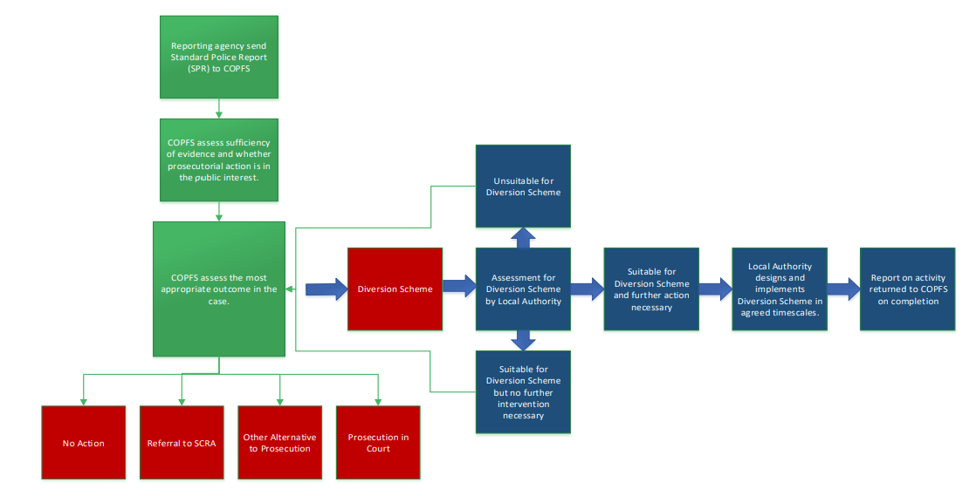  Key Principles  The diversion assessment should be underpinned by the following key concepts:  - The SPR must not be shown to participants for reasons of data protection, although general exploration of the circumstances which led to the individual being reported to Police will be necessary.  - Every referral from COPFS will be subject to a diversion from prosecution assessment.  - It must be clearly explained to the individual that diversion from prosecution is voluntary.  - The final decision on whether to take prosecutorial action lies exclusively with COPFS.  - It is unnecessary to consider concepts of ‘guilt’ or ‘innocence’ when contemplating the role of the individual in a particular incident. Broadly, there is no requirement for an individual to accept guilt in order to receive a disposal of this kind. The key requirement is that they accept the offer of engaging with the relevant support.  - The content of any discussion which forms part of the diversion from prosecution assessment will usually be inadmissible in evidence against the individual for that offence. Where information is voluntarily offered in relation to other potential offences, this may be used by prosecutors.  - Issues relating to the protection of others should be given paramount consideration.  Your data collection throughout this template should help to answer questions about whether or not the existing delivery of diversion meets the standards set out in the guidance on an effective diversion from prosecution provision locally. It is therefore important to have these questions in mind when collecting information about demographics, needs and services locally. If you want to explicitly agree these questions with partners before completing this template there is further guidance on how to do this within the Strategic Needs and Strengths Assessment (SNSA) guidance under the headings “Data Collection Plan”. Any local evaluation of diversion provision will be particularly helpful when considering the key principles locally.  Key Roles  The Police, local authority (Social Work) and the Procurator Fiscal are the main partners involved in the diversion process.  The role of Police as the first point of contact in the community is crucial, as this is where the potential for diversion from prosecution can be first considered. When attending an incident and undertaking the necessary enquiries, the officers involved should capture any antecedent information in respect of presenting mental health, substance misuse, risk and other vulnerabilities and record it within the ‘antecedent details’ section of the Standard Police Report (SPR) when submitted to COPFS.  Is there a single point of contact within Police, locally, for matters relating to diversion? Some important questions to ask them might be:  - How are officers reminded to take cognisance of the needs and circumstances of those present when attending incidents?  - Are Police direct measures regularly considered prior to the consideration of diversion?  - Are any spot checks completed on the recording of antecedent details for quality assurance purposes?  - Is there any locally accessible training regarding the inclusion of further detail on needs and circumstances within antecedent details and how regularly do officers receive it?  - If they do include antecedent information, are they ever informed about the assessment of suitability or the eventual outcome of a diversion?  Include a summary of any identified local strengths or issues within this section.  The role of the Procurator Fiscal is to consider information provided by Police within the SPR. In the first instance, the prosecutor will make a decision on whether there is a sufficiency of evidence, and what prosecutorial action, if any, is in the public interest. Where the prosecutor is satisfied that the public interest would be best serviced by an offer to undertake assessment for diversion from prosecution, they will write to the individual and advise that arrangements are being made for that assessment to be undertaken by the local authority (Social Work). When writing to the individual, the prosecutor will emphasise that participation in the scheme is voluntary and that if they have any queries about the scheme then legal advice should be sought. Once a diversion has been completed, Social Work will submit an outcomes report to the Procurator Fiscal, who will then determine the outcome of the case and either decide to take further prosecutorial action, or to take no further action in the matter. COPFS will advise the individual and Social Work on the final outcome of the case.  Who, within COPFS, is the local contact for case marking? Some important questions to ask them might be:  - How are they assured that key information, which may lead to a decision to divert, is consistently considered and adheres to nationally agreed criteria?  - Are there established mechanisms in place to request further information from Police, if necessary, regarding suitability for diversion?  - Are there any local pathways in place for the Procurator Fiscal to directly refer an individual into services when considering diversion (for example mental health treatment services)?  - What information does the Procurator Fiscal receive from Social Work regarding suitability?  - What information does the Procurator Fiscal require and receive from Social Work during the diversion intervention period?  - What information does the Procurator Fiscal require and receive at the end of the intervention period and how is this communicated to the individual?  Include a summary of any identified local strengths or issues within this section.  The role of Social Work staff is to arrange for an assessment to be carried out as to the suitability of diversion for the individual and to design and deliver the appropriate interventions.  Who, within the local authority (Social Work), oversees diversion? Some important questions to ask them might be:  - What information do Social Work use or receive in order to make a suitability assessment?  - What information is communicated to the individual and other partners (primarily Police and Procurator Fiscal) regarding the decision and how?  - How are individual diversion intervention programmes designed and are any other partners and / or the individual involved?  - Is the report to the Procurator Fiscal shared with the individual at the end of the intervention?  - Do partners know whether people remain engaged with services once diversion has been completed and if so how?  - How does an understanding of local needs which result in offending, and offence types, influence / align with the programmes and interventions offered?  - Are restorative justice approaches available in your area as an option within diversion from prosecution?  Include a summary of any identified local strengths or issues within this section.  Consider whether, time permitting, it would be feasible to set up a local diversion focus group with Police, Social Work and COPFS to talk through each of their key roles and to explore the strengths and potential barriers in delivering diversion provision. Sometimes it is the links between individual agencies within a whole system where the opportunities for improvement action lie.  It would be helpful to seek feedback from individuals about their experience of diversion and the outcomes. Some key questions to ask them might be:  - Was it made clear to them that diversion was a choice?  - Did they receive any information that helped them decide to accept the diversion?  - Was it made clear to them what needs were being addressed – did they agree?  - Did they think the diversion was specific to their needs or to the right needs?  - Did they remain engaged with services after their diversion intervention was completed?  - Were they aware of whether they successfully or unsuccessfully completed their diversion? How did they know?  - Were they clear about the differences between diversion and prosecution in terms of their criminal record?  Include a summary of any identified local strengths or issues within this section.
Demographic profile | There are nationally published data tables available which contain data relating to diversion from prosecution cases, broken down by local authority area, for each year beginning 2004-05:  Number of referrals  Number of assessments undertaken  Number of cases commenced  Number of individuals for which cases commenced  Number of cases successfully completed  Number of cases commenced by gender  Number of cases commenced by age  Number of cases commenced by employment status  Use the tables above to extract data relevant to your local area. This turns data description into data analysis. Provide a narrative as well as a visual description of the data. Provide details of any trends in relation to the diversion data, locally.  Some examples of narrative observations from Scotland wide data are:  - In Scotland as a whole, the number of diversion from prosecution cases commenced rose by 7 per cent between 2017-18 and 2018-19 to over 1,800. This was around the same level as the levels in 2014-15 and 2015-16, prior to the historic high of 2,000 cases in 2016-17.  - During 2018-19, there were 2,900 referrals, 2,800 assessments and 1,400 cases completed.  Some examples of visual descriptions of the data using Scotland wide figures are:  Sometimes, infographics can be used to visually represent data in creative ways. For example:  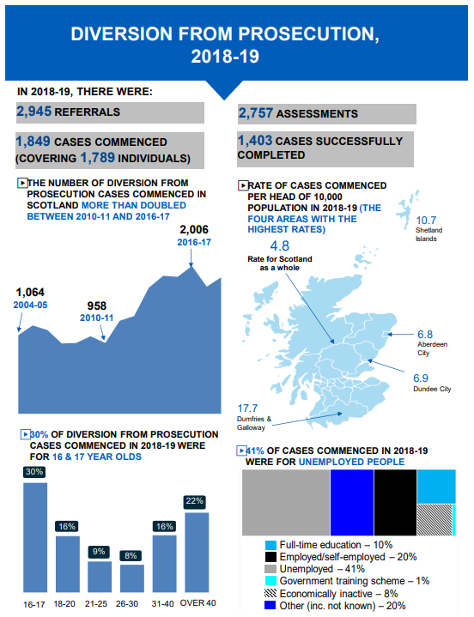  Your COPFS and Social Work partners may be able to provide a further breakdown of data. This will be subject to local processes and protocols around data requests and may take some time to arrange so it is important to factor that in to your planning. Examples of data that might be available locally are:  Data Supplementary Data Agency Responsible  The total number of individuals marked for diversion The nature of the charge for which individuals marked for diversion were reported. COPFS  The total number of individuals rejected following assessment The reasons for which individuals were rejected following assessment Social Work  The total number of individuals progressing to diversion from prosecution intervention. Social Work  The total number of individuals who failed to complete diversion from prosecution intervention. The reasons for which individuals failed to complete diversion from prosecution. Social Work  The total number of individuals who completed the diversion from prosecution intervention. Referrals to partner agencies (and the reason for referrals) and the agencies to whom those referrals were made. Social Work  The total number of individuals subject to an extended diversion from prosecution intervention of beyond three months. The reason an extension was required. Social Work  The number of individuals referred for diversion who were subsequently marked for prosecution. COPFS
Needs profile | There are nationally published data tables relating to diversion from prosecution cases, broken down by local authority area, which indicate the needs profile of people subject to diversion in each local authority area relating to:  Number of cases referred to drug treatment / education services  Number of cases referred to alcohol treatment services  Number of cases referred to mental health services  Use the tables above to extract data relevant to your local area. Provide a narrative as well as a visual description of the data. Provide details of any trends in relation to the referral data.  Include a summary of any identified local strengths or issues within this section.  Using Scotland wide data, the following is an example of how needs data might be represented:  It is really important to caveat your data if necessary. For example, in the graph above it is important to state that information on cases referred to alcohol and mental health services was collected for the first time in 2012-13.
Services profile | Diversion interventions should be bespoke to the individual and designed to address identified needs. The services involved in addressing need are likely to be universal services available across the community planning landscape.  Work with your Social Work partners to establish how services for diversion interventions are identified. Provide an overview of the services that are commonly used in diversion interventions. Are there any established fast track pathways into these services for people subject to diversion? Are there any barriers to accessing services? Have any recent evaluations of services been completed?  Once you have identified the services involved in the delivery of diversion you may consider the development of a questionnaire to inform your service map locally. This could include information about:  - Organisation Details - Name, composition, nature of engagement with CJP  - Service Details – Name, purpose, eligibility criteria, engagement period, whether voluntary or statutory, needs addressed, referral pathway  - Service Delivery – Stage(s) of the justice process, current delivery, potential delivery  - Demographic Data – Number of people, gender, age range, employment status  - Outcomes Data –Link to national community justice outcomes, link to local CJOIP outcomes, outcomes data held, process for recording outcome data  - Funding – Funder(s), funding cycle, tendering process, funding trends, decommissioned services.  Once you have information about services it may be helpful to use an index to further understand the provision locally. For example, the following table shows how services involved in the delivery of diversion might be mapped against the needs that they aim to address:  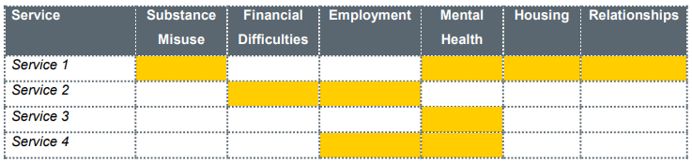  This will be particularly helpful to establish how the services compare / map against the needs identified. Include a summary of any identified local strengths or issues within this section.
Horizon Scanning | Horizon scanning techniques will be particularly helpful and are explained in more detail in the SNSA guidance. Horizon scanning is an overarching term for identifying and then analysing future impacts on the topic or theme for a SNSA, to allow policy makers to consider how these effect delivery and practice. A properly executed horizon scanning exercise can be hugely beneficial to a proactive partnership to enable it to maximise opportunities for change or mitigate risks, rather than merely react.  As provided within the SNSA guidance, horizon scanning can be achieved effectively by considering issues under headings covered by the PESTELO acronym. It is also helpful to conduct a SWOT analysis as part of a horizon scan to support analysis of how issues will affect your partnership and what might need to be actioned against these.  An example of an emerging issue to consider as part of a horizon scanning exercise is the COVID-19 pandemic. This crosscuts all themes included in PESTELO, as this will have a range of implications for local partnerships in the delivery of diversion from prosecution. From a national perspective, the following information can be provided on the impact of COVID-19 in this area.  In June 2020 an agreement was established between Social Work Scotland and COPFS. Its purpose is to offer guidance in respect of diversion from prosecution for the duration of the Covid-19 pandemic.  The current timescale for the assessment report is that it should be received within 20 days of the request being sent by COPFS and the intervention then completed within around 3- months. The statutory time bar contained in the Criminal Procedure (Scotland) 1995 Act places a 6-month time limit on the commencement of summary proceedings for certain statutory offences. This has been extended to 12 months. This will include cases which have already been reported to COPFS and which are in the diversion system.  COPFS are currently filtering out as many new cases as is reasonably possible from the diversion process and ensuring that staff are aware that when marking for diversion they must be aware that there will be risk of the intervention not being completed in the timescale allocated. Based on the emergency legislation contained in the Coronavirus (Scotland) Act 2020 COPFS have reassessed timescales:  - Assessments should be completed in 28 days wherever possible but no later than within 6 – 8 weeks of the request being sent by COPFS. This will be kept under regular review as the justice system moves through the phases of the Coronavirus (COVID-19): Scotland's Route Map.  - Interventions should be completed within 6 months of the return of the assessment to COPFS.  If the assessment has already been undertaken and the diversion is ongoing then an additional 6 months should be added to the target completion date of the intervention. If there are specific local issues arising please that are non-urgent, these should be communicated directly back to COPFS but expect a response to be slower than normal.  Figures available for the period of pandemic 1 April to 31 July 2020 (via SWS) provide some indication of the operation of diversion from prosecution during this time. It should be noted that data was only received from 26 local authority areas.  - 1,022 referrals to Local Authority from COPFS were received.  - 584 cases commenced within Local Authority Areas.  - 288 cases were completed within Local Authority Areas.  Based on referral numbers within a standard year for 26 LA’s (2662 total in 2017/18) this appears to be a significant increase in this type of early intervention, with an equally positive increase (albeit lesser) in cases commencing against a standard year (without being able to identify whether larger or smaller Local Authorities are included). This could be seen to demonstrate the effectiveness of this tool while dealing with the pandemic, but also of its potential as a swift and effective community justice option.  Work with all relevant partners in a workshop capacity to complete a horizon scan and related SWOT analysis against diversion from prosecution. Where this is not possible, completed matrices should be shared with partners for their comment and inclusion of specific impacts. The impact of the pandemic to your partners should also be understood on diversion from prosecution as part of this analysis. Priority themes emerging from a horizon scan can be either included throughout a SNSA or attached as an appendix to that. These will need considered when forming outcomes and action as part of the subsequent plan where appropriate.  Include a summary of any identified local strengths or issues within this section.
Other information | It is helpful here for CJPs to consider how outcomes for people, relevant to the presenting needs of people within diversion, are being achieved within other strategic landscapes. This might include the local outcome improvement plan for the area, the health and social care (integration joint board) strategic plans, local health improvement plans and alcohol and drug partnership activity. Exploring priority outcomes may identify common actions which can be shared and developed in partnership.  Include a summary of all additional information within this section.
Data analysis and inference development | The following are examples of inferences that might be drawn from Scotland wide data:  - Between 2017-18 and 2018-19, the number of cases commenced rose for all age groups except the over 40s. Those aged 16 to 20 are substantially over-represented when the population base is taken into account – they accounted for 46 per cent of people getting diversion from prosecution in 2018-19 but only 8 per cent of the population aged 16 to 70. This continues to reflect a general focus on diversion for younger people.  - Historically, diversion involves relatively low volumes compared to other fiscal disposals such as fines and warnings, or court proceedings.  By collating all of the information in this template, what can you say (either conclusively or hypothetically) about diversion in your local area? It is important to consider all conclusions based on your assessment of evidence. Where you identify good practice consider how this can be scaled up, replicated or shared. Where you can only hypothesise shows where there are gaps in your evidence picture which will require to be addressed with more information. Filling those gaps can be improvement activity in itself.  What are the needs that people face and their potential causes, and what action can be taken to address these? Where are the strengths in service delivery and where are the gaps or opportunities for improvement?  Your Police and Social Work partners may be able to provide a further breakdown of locally-specific data. This might provide further insight into trends in crime committed and the needs that have been identified in relation to diversion. This will give the opportunity to explore potential causes and consider whether interventions offered as part of diversion from prosecution can effectively address both offending and its causal factors. The following provides an example:  - Police crime data identifies rising offences of shoplifting within the local area.  - COPFS data shows local cases of shoplifting are increasingly marked for diversion from prosecution.  - Mapping of Police crime data provides this increase is more prevalent within areas experiencing higher levels of deprivation.  - Social Work data identifies substance misuse and unemployment to be the main needs to address for individuals involved in shoplifting.  Considerations: Are interventions available as part of diversion aligned effectively to the offence type and needs and causal factors identified? What does the Local Outcome Improvement Plan set out in response to deprivation in the areas identified? Can diversion from prosecution activity link to existing provision to address deprivation in these areas, where this is not already achieved?  CJS are due to deliver an on-line inference development session by the end of December 2020 which may help in determining what your data and information is telling you about diversion locally.  Benchmarking can be a useful tool to make comparisons, set goals and measure performance. For example, local data on diversion could be displayed alongside other local authorities or against Scotland wide data to see whether trends are comparable.  Benchmarking other, related, data is also helpful in assessing the impact of improvement activity related to diversion. Setting diversion in the context of other related data will help CJPs to develop measures that will enable them to monitor progress. For example, CJPs may wish to set diversion data against local data in relation to Police direct measures, fiscal work orders and community payback orders in order to monitor trends. If diversion numbers go up over time, for example, this may be seen as a success. However, if benchmarking shows that Police direct measures or fiscal work orders have decreased by a proportional rate then this would merit further investigation.
Recommendations and priority setting | You should now have a range of quantitative and qualitative data and information available to you about diversion in your local area. Using the data analysis and inference development section as a basis, list the items that you have identified as strengths alongside the items that require improvement (referred to as improvement activity).  Improvement activity should now by prioritised. This doesn’t mean that improvement activity that doesn’t reach the top of the list will never get done; it might get done at a later time, it might be that it cannot be completed until something else is done or it might mean that resource needs to be freed up at a later date. The CJP can use this SNSA template, once complete, as an audit trail of decision making and to ensure that improvement activity that isn’t prioritised doesn’t get forgotten.  An impact versus effort matrix is a simple tool that can help to generate conversation and aid partners in their decisions making regarding prioritisation:  High Impact High Effort – “Major Projects”  High Impact Low Effort – “Easy Wins”  High  Impact  High Effort Low Impact – “Thankless Tasks”  Low Impact Low Effort – “Low Hanging Fruit”  Low  Low  Effort  High  CJPs can set the axes on the above matrix according to what will be the most helpful to make an informed choice regarding prioritisation. As well as impact and effort, as shown in the example, CJPs might consider changing the axes to importance versus urgency, cost versus benefit or risk versus reward.  Placing the identified improvement activity on the matrix is best done collaboratively as a group activity as it will probably take some conversation and debate before reaching an agreed position for each.  Developing a scoring criteria is another method that can be helpful in prioritising activity. You might ask partners to assign a score across a range of criteria. For example:  Improvement Activity Critical to Meeting Standards Strategic Value Ease Benefit to the Individual Cost Resource Impact Overall Priority  Imp Activity 1 4 1 3 3 5 2 3  Imp Activity 2 5 2 4 4 4 5 4  Imp Activity 3 1 1 5 1 3 4 2.5  For this table, you could set the following priority ratings:  Critical to meeting standards? Is the improvement activity crucial to meet standards as set out in the diversion guidance? 1 = Critical 5 = Not critical  Strategic Value? Is the improvement activity important to your overall strategy? 1 = Highly important 5 = Not important  Ease? Will the improvement activity be fairly east to complete? 1 = Very easy 5 = Very difficult  Benefit to the individual? Will the improvement activity likely yield significant benefit to the individual? 1 = Highly likely 5 = Not likely  Cost? Will the improvement activity likely cost a lot? 1 = Low cost 5 = High cost  Resource impact? Will the improvement activity have a great impact on CJP resource? 1 = Low impact 5 = High impact  Overall priority: Average score of all five criteria  Note: In this example, the lower the score the higher the improvement activity’s priority  It is important to remember that this template is one of a number that will make up a whole SNSA for the local area. Therefore, this technique should also be considered to prioritise all improvement activity being considered for inclusion in the area’s CJOIP.
Developing outcome improvement actions | Once the CJP have decided on the priority improvement activity for diversion provision in the area, consideration needs to be given to how this will be expressed within the CJOIP.  A good way to approach this is to write an objective which describes what the CJP are trying to achieve. Use the SMART acronym to define how the CJP are going to know if the improvement activity is successful:  Specific – outline in a clear statement precisely what is required  Measurable – include a measure that will enable the CJP to monitor progress and to know when the objective has been achieved  Achievable – ensure there is commitment and capacity to carry out the necessary activity  Realistic – ensure there are no factors which would make the achievement of the objective impossible or unlikely  Time-bound – agree the date by which the activity must be completed  The CJP should now be able to answer the following questions about diversion in the local area:  - What recommendations can you make to improve diversion provision in the local area?  - Who do the recommendations impact on in terms of action and delivery?  - What is the intended impact of the actions that follows a recommendation?  - What are the priority areas for action arising from the SNSA for diversion in the area?

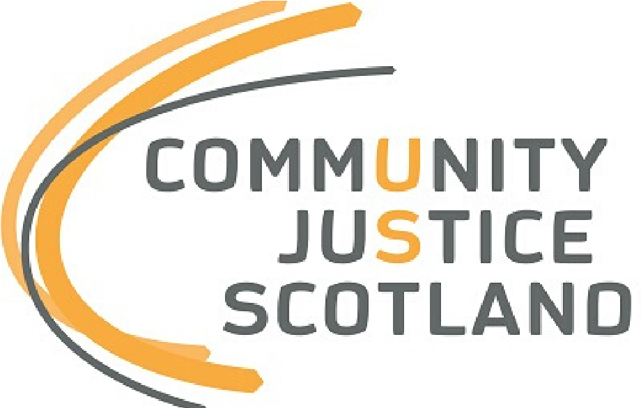

First published December 2020

Community Justice Scotland, R1 Spur Saughton House, Edinburgh, EH11 3DX

Tel: 0300 244 8420

www.communityjustice.scot

https://www.gov.scot/publications/criminal-justice-social-work-statistics-scotland-2018-19/pages/4/

